2025-2026 Mustang Booster Club
Membership Form

Donation Levels | Donation  (please circle)
MUSTANG FAMILY Gold: $25 Stang Shop Certificate | $150
MUSTANG FAMILY Green: $10 Stang Shop Certificate | $75
MUSTANG FAMILY White | $30
MUSTANG Faculty | $15
MUSTANG BUSINESS: Includes marketing and name recognition on the wall in Moody Gym.  (Provide logo in vector format to hempsteadboosterclub@gmail.com) | $150

Member -or- Business name:__________________________________________________________________

Address: ____________________________________________________________________________

City: ______________________________ State: ______________ Zip: ______________

Phone: ____________________________ Email(s): _________________________

Student(s) name(s) and grade(s): _____________________________________________________

Thank you for your support in promoting Mustang academics, activities, arts, and athletics!

BECOME A VOLUNTEER: (please check)
_____Stang Apparel Shop _____Membership _____Special Events _____Board Member

Please return completed form to:
Hempstead High School
c/o Mustang Stampede/Wanda Wallace
3715 Pennsylvania Avenue
Dubuque, IA 52002

Pay by check, payable to: Hempstead Booster Club
-OR- Paypal:

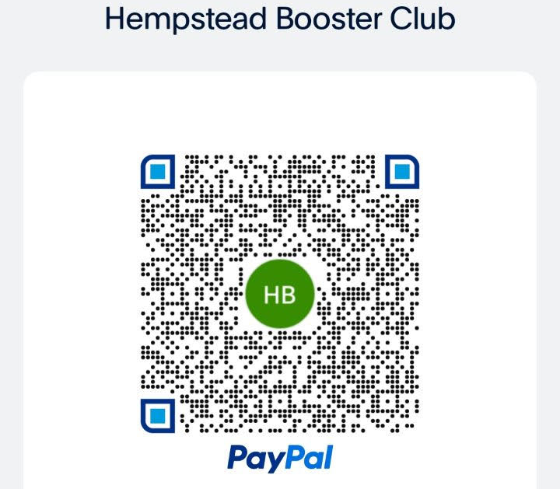

Note: For seniors to be eligible to apply for scholarships, student’s families must be paid members, at any level, as of October 1, 2025.

