Summer 2022 AP Lang and Comp Reading List
Ms. Dianne Koch – 563-663-3125 – dkoch@dbqschools.org
Ms. Haley Lammer-Heindel – 641-781-1655 – hlammerheindel@dbqschools.org

Welcome to AP Language and Composition class! Our year-long format with an American Literature emphasis will align with AP U.S. History. This English class will focus on a variety of writing assignments that you would find assigned in college classrooms. An emphasis on fiction, non-fiction, and argumentative readings will strengthen your reading and critical thinking skills.

Here are the summer books and assignments (all to be read and done by the first day of school) Please write all responses in black or blue ink (thank you). You may type if that is easier. With all these works, please note how the writer uses language to create meaning. On the college level, seldom are you quizzed over intricacies of the plot; instead, themes and symbolism as well as nuanced language take center stage.

The Glass Castle, written in 2005 by Jeannette Walls, tells the autobiographical story of a daughter’s journey to understand and accept her formative years while living in a dysfunctional family. The memoir recounts the unique challenges of being raised by unpredictable, and at times unstable, parents. Walls invites her readers into the personal nooks and crannies of her life from adolescence through adulthood. Fill out The Glass Castles characters and Soapstone worksheet as you read.

Flannery O’Connor short stories will comprise the second “text.” Read these stories with quirky plot lines and characters. As a Southern writer, she also is classified as a Gothic writer. Find themes that resonate between the stories. O’Connor is a graduate of the Iowa Writers’ Workshop, a prestigious University of Iowa graduate school of international acclaim. Her sense of humor, use of irony, and use of the grotesque are hallmarks of her writing. Fill out the attached comparison chart. Also choose two quotes from each story for a total of six, focusing in on details, insights, ironies, language usage, or themes. See the details on the double-entry journal assignment.

******************************************************************************
Texts which may be read during the school year:
Sand County Almanac Literary nonfiction essays, op-eds, speeches
I Know Why the Caged Bird Sings The Glass Castle
The Things They Carried The Grapes of Wrath
The Great Gatsby Fast Food Nation excerpts
The Devil in the White City Nickel and Dimed
The Jungle excerpts Uncle Tom’s Cabin excerpts
Any new texts the district adopts over the summer

-Numerous nonfiction essays from The Language of Composition, Ideas in Argument, and The Bedford Reader. -Various short stories from different literary eras that complement the novels, essays, and nonfiction readings.
******************************************************************************
Please call or email if you have any questions. Have a safe and fun summer. We look forward to meeting you.
– Ms. Koch and Ms. Lammer-Heindel

The Glass Castle – Jeannette Walls Name_______________________
CHARACTERS: For each of the following characters, take notes on how Jeannette (the author/narrator) describes them. What is her perception of them? How does she show this to the reader?
Dad
Mom
Lori
Brian
Maureen
Grandma Smith
Erma
Uncle Stanley
Billy Deel
Grandpa Walls
Eric
John
How would you describe Jeannette? Why?

How does Jeannette describe herself? Give textual evidence to support your answer.

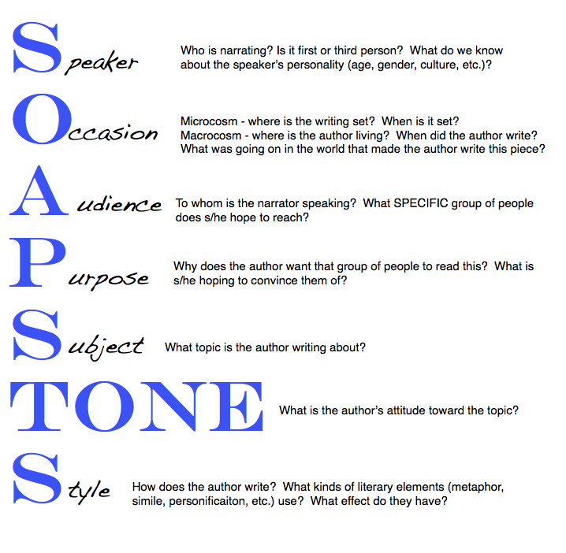
For each section of the book, take notes on the following: Subject, Occasion, Audience, Purpose, Speaker, Tone
I.A Woman on the Street (Chapter 1)

S
O
A
P
S
Tone

II. The Desert (Chapter 2-28)
S
O
A
P
S
Tone

III. Welch (Chapter 29-55)
S
O
A
P
S
Tone
IV. New York City (Chapter 56-69)
S
O
A
P
S
Tone

V. Thanksgiving (Chapter 70)
S
O
A
P
S
Tone

Flannery Connor Short Stories Comparison Chart
Find these short stories on the internet by Googling:
Good Country People pdf
A Good Man is Hard to Find pdf
The Life You Save May Be Your Own pdf
Read each short story and fill out the following information for class discussion.
Name:
Title | Good Country People | A Good Man is Hard to Find | The Life You Save May Be Your Own
Setting

Character with descriptions

Plot

Symbols

Themes

O’Connor Quote Double-Entry Journal: Write down two quotes from each story for a total of six entries.

Write a 5-7 sentence paragraph on any of the following: commentary, insights, questions, O’Connor’s argument, interesting language, symbolism, metaphor/simile, imagery, diction, syntax, tone, or theme. Do deep thinking, not surface thinking. Do not summarize but truly analyze the author’s motivation for your commentary or insight, the effect of what you are discussing, how the author is creating meaning, or why the author’s point is effective (or not) here. Please type your responses by downloading or printing the document below, expanding the boxes as needed. Do not try to handwrite full paragraphs in the limited space. Thanks!

Flannery O’Connor Double Entry Journal Name ________________________ Pd. ____
Story and Quote | Your commentary, insights, questions, O’Connor’s argument, interesting language, symbolism, metaphor/simile, imagery, diction, syntax, tone, or theme discussion.
Good Country People

Good Country People

Good Man

Good Man

The Life You Save

The Life You Save

